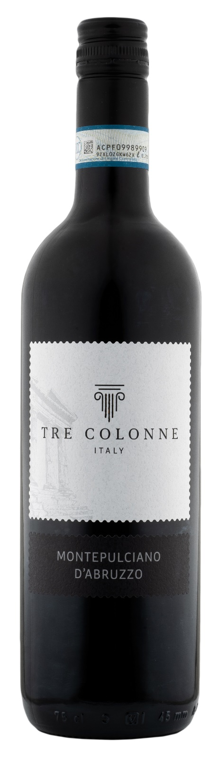
MONTEPULCIANO ABRUZZO DOC – TRE COLONNE

Grape: Montepulciano 100%
Alc. Vol.%: 12,5
Vintage: 2024
Residual sugar g/l: 6,0
Total acidity g/l: 5,4
Region: Abruzzi
Production zone: Vineyards in the Abruzzi region
Capacity: 750ml

CHARACTERISTICS

Vinification: Once the fermentation is over the wine is aging in steel tanks where the malolactic fermentation takes place and is then conserved for further 6 months
Aging: In steel tanks until bottling
Yield per ha: 14000kg
Colour: Intense red with purple reflections
Bouquet: Notes of herbs and spices
Flavour: Medium bodied, fruity, vigorous

SERVING SUGGESTIONS

Best enjoyed with starters, savoury first courses and pizza.
Serving temperature 18 °C
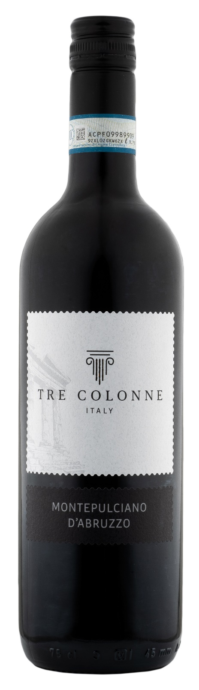
TECHNICAL INFORMATION / PALLETIZING

Size 750ml:
Article Nr. V14005A
GTIN-13 bottle 8017868004974
GTIN-13 carton 8017868005513
Closure Cork/Screwcap
Bottles / carton 6 bottles
Pallet size 80x120cm
Cartons/layer 25
Cartons/pallet 125
Kg/carton 7,0
Kg/pallet 892

Contains sulphites
GMO Free
Revisione 01. 28.03.2025

